**UNEARTHING THE ENVIRONMENTAL IMPACT OF HUMAN ACTIVITY: A GLOBAL CO2 EMISSION ANALYSIS**

**Project Report**

1. **INTRODUCTION:**

**1.1 OVERVIEW:**

CO2 Emission refers to the Carbon dioxide emitted throughout the world. Fossil fuel use is the primary source of CO2. Global warming is one of the biggest challenges currently being faced by the human race, although warming is due to increased atmospheric carbon dioxide from human activities.

**1.2 PURP0SE:**

We will be focusing on CO2 Emissions and its effects on the world we live in as well as some key factors and stats that may play a role in the emission of CO2 globally. This will help researchers and environment experts to predict global warming. So countries should set a goal to decrease this amount yearly.

1. **Problem Definition and Design Thinking:**

**2.1EMPATHY MAP:**

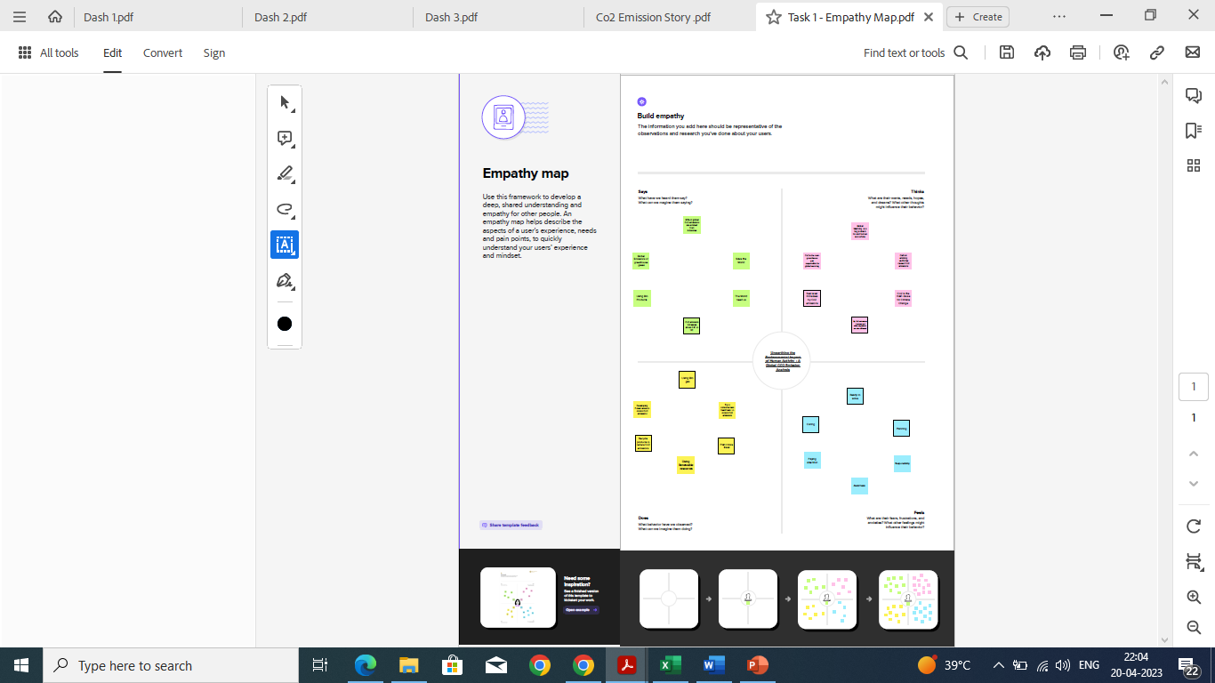

* 1. **Ideation & Brain Storming Map:**



1. **RESULT:**

**3.1 Dashboard:**

Dashboard 1:

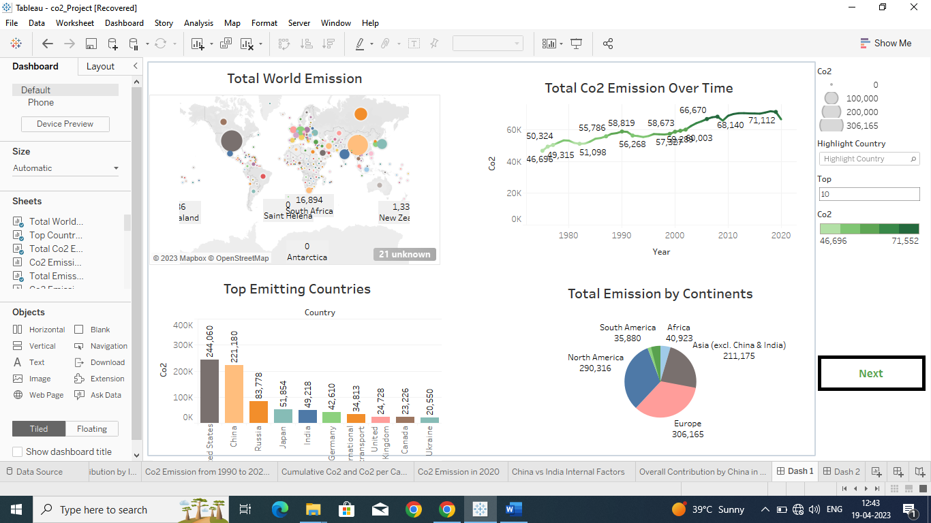

Dashboard 2:

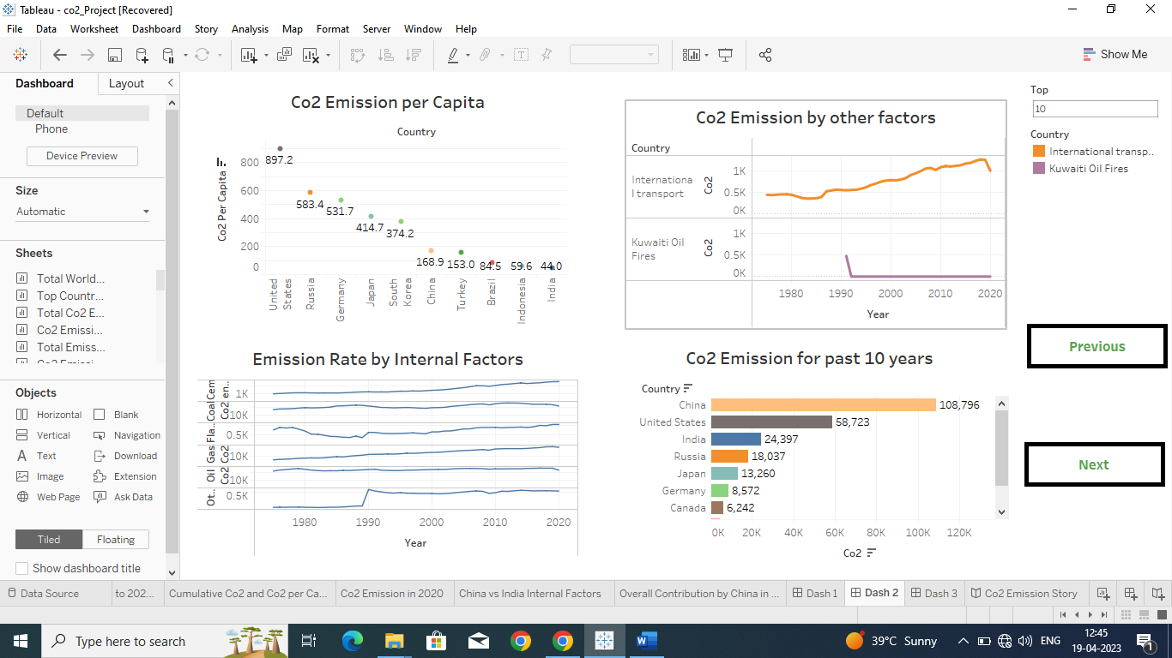

Dashboard 3:

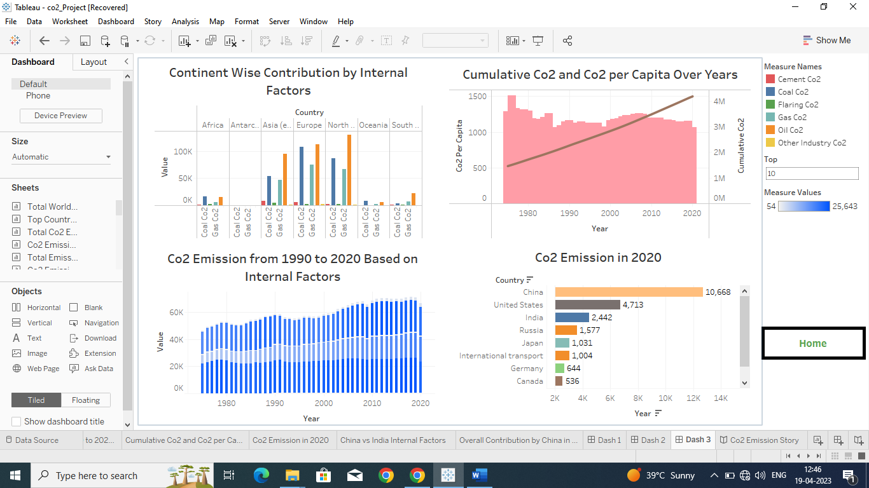

* 1. **Story:**

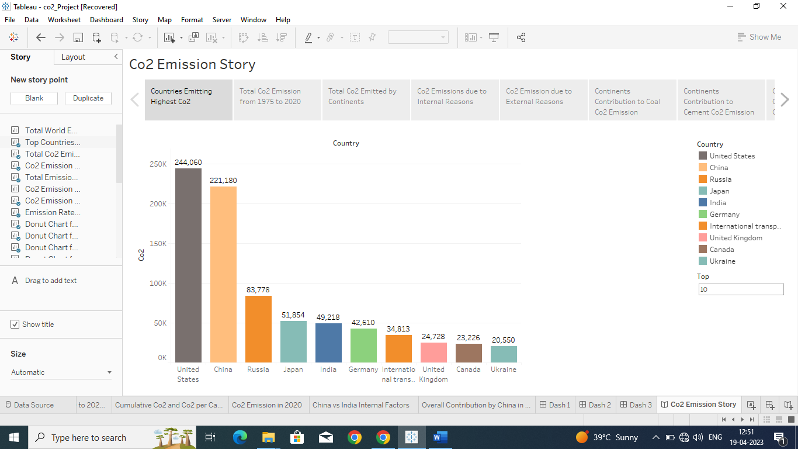

1. **1. ADVANTAGES:**

* Improve air quality and save lives.
* Green plants grow faster with more CO2.
* Air pollution and Greenhouse gases are often released from the same sources, cutting greenhouse gas emissions in an effort to slow climate change also reduces air pollutants.

**2. DISADVANTAGES OF SOLUTION:**

* When we burn oil, coal and gas, we don’t just meet our energy needs, we drive the current global warming crisis as well.
* Fossil fuels produce large quantities of carbon dioxide when burned.
* Carbon emissions trap heat in the atmosphere and lead to climate change.

1. **APPLICATIONS:**

Carbon dioxide is used as a refrigerant, in fire extinguishers, for inflating life rafts and life jackets, blasting coal, foaming rubber and plastics, promoting the growth of plants in greenhouses, immobilizing animals before slaughter and in carbonated beverages.

1. **CONCLUSION:**

The rising level of atmosphere co2 could be the one global natural resource that is progressively increasing food production and total biological output, in a world of otherwise diminishing natural resources of land, water, energy, minerals and fertilizer.

1. **FUTURE SCOPE:**

In the Annual Energy Outlook (AEO2022) Reference case, which assumes no changes to current laws or regulations, the U.S. Energy Information Administration (EIA) projects that U.S. energy-related carbon dioxide (CO**2**) emissions will fall to 4.5 billion metric tons in 2037, or 6% below the energy-related CO**2.**

**APPENDIX:**